**SQL Training**

Course-End Project Solution



**Course-End Project: Air Cargo Analysis**

1. **Create an ER diagram for the given airlines database.**

1. **Write a query to create route_details table using suitable data types for the fields, such as route_id, flight_num, origin_airport, destination_airport, aircraft_id, and distance_miles. Implement the check constraint for the flight number and unique constraint for the route_id fields. Also, make sure that the distance miles field is greater than 0.**

**SQL code:**

CREATE TABLE route_details (

route_id INT NOT NULL UNIQUE,

flight_num INT NOT NULL CHECK (flight_num > 0),

origin_airport CHAR (3) NOT NULL,

destination_airport CHAR (3) NOT NULL,

aircraft_id INT NOT NULL,

distance_miles SMALLINT NOT NULL CHECK (distance_miles > 0),

PRIMARY KEY (route_id)

);

**Output:**



1. **Write a query to display all the passengers who have travelled in routes 01 to 25 from the passengers_on_flights table.**

**SQL code:**

SELECT * FROM passengers_on_flights WHERE route_id between 01 AND 25;

**Output:**

1. **Write a query to identify the number of passengers and total revenue in business class from the ticket_details table.**

**SQL code:**

SELECT COUNT (class_id) Bussiness_Class, SUM(price_per_ticket) revenue_in_bussiness FROM ticket_details WHERE class_id = 'Bussiness';

**Output:**



1. **Write a query to display the full name of the customer by extracting the first name and last name from the customer table.**

**SQL code:**

SELECT CONCAT(first_name,' ',last_name) FULL_NAME FROM customer;

**Output:**

1. **Write a query to extract the customers who have registered and booked a ticket from the customer and ticket_details tables.**

**SQL code:**

SELECT customer.customer_id,customer.first_name,customer.last_name,ticket_details.p_date

FROM customer

INNER JOIN ticket_details

ON customer.customer_id = ticket_details.customer_id;

**Output:**

1. **Write a query to identify the customer’s first name and last name based on their customer ID and brand (Emirates) from the ticket_details table.**

**SQL code:**

SELECT first_name, last_name FROM customer

WHERE

customer_id IN (SELECT customer_id FROM ticket_details WHERE brand = 'Emirates');

**Output:**

1. **Write a query to identify the customers who have travelled by *Economy Plus* class using Group By and Having clause on the passengers_on_flights table.**

**SQL code:**

SELECT customer_id, aircraft_id, route_id, depart, arrival, seat_num, class_id, travel_date, flight_num FROM passengers_on_flights

GROUP BY customer_id, aircraft_id, route_id, depart, arrival, seat_num, class_id, travel_date, flight_num

HAVING class_id = 'Economy Plus';

**Output:**

1. **Write a query to identify whether the revenue has crossed 10000 using the IF clause on the ticket_details table.**

**SQL code:**

SELECT IF(SUM(Price_per_ticket)>10000,'Revenue is greater than 10000','Revenue is less than 10000') Check_if_revenu_greater_than_10000 from ticket_details

**Output:**

1. **Write a query to create and grant access to a new user to perform operations on a database.**

**SQL code: Create a new user**

CREATE USER junior@localhost

IDENTIFIED BY 'junior123';

**SQL code: Grant user access**

GRANT EXECUTE ON securitydb.*

TO junior@localhost;

1. **Write a query to find the maximum ticket price for each class using window functions on the ticket_details table.**

**SQL code:**

SELECT *, MAX(Price_per_ticket) OVER ( PARTITION BY class_id ) max_price

FROM ticket_details;

**Output:**

1. **Write a query to extract the passengers whose route ID is 4 by improving the speed and performance of the passengers_on_flights table.**

**SQL code: Create index**

CREATE INDEX route_id ON passengers_on_flights (route_id);

SELECT customer_id,depart,arrival,aircraft_id FROM passengers_on_flights WHERE route_id = '04';

**Output:**

1. **For the route ID 4, write a query to view the execution plan of the passengers_on_flights table.**

**SQL code:**

SELECT * FROM passengers_on_flights WHERE route_id = '04';

**Output:**

1. **Write a query to calculate the total price of all tickets booked by a customer across different aircraft IDs using rollup function.**

**SQL code:**

SELECT customer_id, aircraft_id, SUM(Price_per_ticket) as Total_Price FROM ticket_details GROUP BY customer_id, aircraft_id WITH ROLLUP;

**Output:**

1. **Write a query to create a view with only business class customers along with the brand of airlines.**

**SQL code:**

CREATE VIEW BussinessClassView AS SELECT customer_id, class_id, brand from cep_ticket_details where class_id = "Bussiness";

select * from BussinessClassView;

**Output:**

1. **Write a query to create a stored procedure to get the details of all passengers flying between a range of routes defined in run time. Also, return an error message if the table doesn't exist.**

**SQL code:**

DROP PROCEDURE IF EXISTS getPassengersBetweenRoutes;  
DELIMITER &&  
CREATE PROCEDURE getPassengersBetweenRoutes(  
   IN route_a INT,  
   IN route_b INT)  
BEGIN  
DECLARE EXIT HANDLER FOR SQLEXCEPTION  
  BEGIN  
    GET DIAGNOSTICS CONDITION 1  
    @sqlstate = RETURNED_SQLSTATE,  
    @errno = MYSQL_ERRNO,  
    @text = MESSAGE_TEXT;  
    SET @full_error = CONCAT("SQLEXCEPTION Handler - ERROR ", @errno, " (", @sqlstate, "): ", @text);  
    SELECT @full_error AS msg;  
  END;  -- MySQL Query  
  SELECT * FROM passengers_on_flights WHERE route_id BETWEEN route_a AND route_b;  
END &&CALL getPassengersBetweenRoutes(1,25);

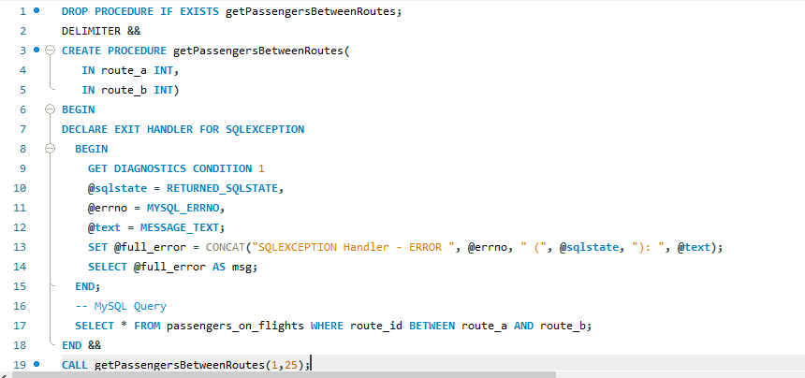

**Output:**

1. **Write a query to create a stored procedure that extracts all the details from the routes table where the travelled distance is more than 2000 miles.**

**SQL code:**

DELIMITER &&

CREATE PROCEDURE Get_Customers_With_2K()

BEGIN

SELECT * FROM cep_routes where distance_miles>2000;

END &&

CALL Get_Customers_With_2K();

**Output:**

1. **Write a query to create a stored procedure that groups the distance travelled by each flight into three categories. The categories are, short distance travel (SDT) for >=0 AND <= 2000 miles, intermediate distance travel (IDT) for >2000 AND <=6500, and long-distance travel (LDT) for >6500.**

**SQL code:**

DROP PROCEDURE IF EXISTS getTravelType;

DELIMITER $$

CREATE PROCEDURE getTravelType()

BEGIN

DECLARE dist INT DEFAULT 0;

DECLARE done BIT DEFAULT FALSE;

DECLARE route_cur CURSOR FOR SELECT distance_miles FROM cep_routes;

DECLARE CONTINUE HANDLER FOR NOT FOUND SET done = TRUE;

OPEN route_cur;

CREATE TEMPORARY TABLE IF NOT EXISTS cep_routes_2 (

travel_type VARCHAR(3)

) AS ( SELECT * FROM cep_routes);

while_label: WHILE done = FALSE DO

FETCH route_cur INTO dist;

IF dist >=0 AND dist <= 2000 THEN

UPDATE cep_routes_2

SET travel_type = "SDT"

WHERE distance_miles = dist;

ELSEIF dist >2000 AND dist <=6500 THEN

UPDATE cep_routes_2

SET travel_type = "IDT"

WHERE distance_miles = dist;

ELSEIF dist >6500 THEN

UPDATE cep_routes_2

SET travel_type = "LDT"

WHERE distance_miles = dist;

ELSE

ITERATE while_label;

END IF;

END WHILE while_label;

SELECT * FROM cep_routes_2 ORDER BY distance_miles;

END$$

CALL getTravelType();

**Output:**

1. **Write a query to extract ticket purchase date, customer ID, class ID and specify if the complimentary services are provided for the specific class using a stored function in stored procedure on the ticket_details table.**

**Condition:**

* **If the class is *Business* and *Economy Plus,* then complimentary services are given as *Yes,* else it is *No***

**SQL code: Create stored function**

DELIMITER $$

CREATE FUNCTION complimentary_servicess(class_id VARCHAR(225))

RETURNS VARCHAR(2255) DETERMINISTIC

BEGIN DECLARE complimentary_servicess VARCHAR(2255);

IF class_id = 'Bussiness' THEN SET complimentary_servicess = 'Yes';

ELSEIF class_id = 'Economy Plus' THEN SET complimentary_servicess = 'Yes';

ELSE SET complimentary_servicess = 'No' ;

END IF; RETURN (complimentary_servicess); END$$

DELIMITER $$;

**SQL code: Create stored procedure to call stored function**

DELIMITER $$

CREATE PROCEDURE Extra_complimentary_services() BEGIN

SELECT p_date,customer_id,class_id,complimentary_servicess(class_id) as Extra_complimentary_services FROM ticket_details ORDER BY class_id;

END$$ DELIMITER ; call Extra_complimentary_services();

**Output:**

1. **Write a query to extract the first record of the customer whose last name ends with Scott using a cursor from the customer table.**

**SQL code:**

DELIMITER $$

CREATE PROCEDURE first_last_name_is_scott()

BEGIN DECLARE a VARCHAR(255);

DECLARE b VARCHAR(255);

DECLARE cursor_1 CURSOR FOR SELECT first_name,last_name FROM customer

WHERE last_name = 'Scott';

OPEN cursor_1;

REPEAT FETCH cursor_1 INTO a,b;

UNTIL b = 0 END REPEAT;

SELECT a as first_name, b as last_name;

CLOSE cursor_1;

END;

$$ DELIMITER ;

call first_last_name_is_scott();

**Output:**

